5.3.1 The Fundamental Theorem of Calculus

Introduction: The first part of the fundamental theorem of calculus deals with functions of the form:
.
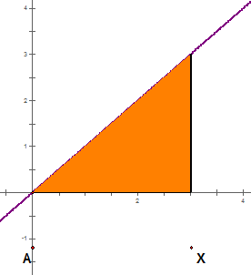
This is a strange looking function.
Suppose that , then we have .
We notice that when , is the area between the line and the portion of the t-axis (like the x-axis) from 0 to x. This is pictured to the right.

In the case that , is the area of the region between the line and the portion of the t-axis from x to 0. This is because when both and the heights of our rectangles in any Riemann sum are nonpositive.

Note: If time permits, the instructor will demonstrate the ideas above with the computer.

So, is the area of a triangle with base length and height .

Thus, we have that: .
(Note that this implies that the graphs of the functionsand are the same!)

Question to the Class: Do you see any awesome relationship between the function of integration in the introduction and the formula we obtained for ?

We see that which is the same as assuming we replace the t with an x. From this we suspect that there may be a profound and deep relationship between integration and differentiation!

Theorem (The Fundamental Theorem of Calculus, Part 1): If f is a continuous function on , then the function g defined by
where

is continuous on and differentiable on , and .

Proof:
Let f be a continuous function on and let where .
We will try to determine the value of .

We note that by the definition of the derivative: .

We then use properties of the definite integral to rewrite the given expression:

Interestingly this resembles the average value of the function on the interval .

However, since f is a continuous function on then it must be a continuous function on since the values of x and are between a and b.

Therefore, by the MVT for Integrals there must be a value of c in the interval such that:

So we can say .

However we should note that as the interval of will shrink and thus all values within this interval will be pushed towards x. Therefore we can say that as we can expect , and since f is continuous on this interval we can write:

Therefore we have found that:
.

Since f is continuous on it must be defined for all values on and thus is differentiable on and therefore continuous on . An additional argument with one sided limits can be used to show that is continuous on .

Note: Intuitively, the fundamental theorem of calculus tells us the unexpected and amazing result that the integral in a sense “undoes” a derivative!!!
Example 1: Find the first derivative of the function .

Since is continuous on for any real number , then by the FTCP1 we have that:

Example 2: Find the first derivative of the function .
We first note that

Since is continuous on for any real number , then by the FTCP1 we have that:

Example 3: Find the first derivative of the function .

We know that is continuous on for any real number , however the derivative here is bit more complicated to compute.

We note that if and then , therefore we must use the chain rule to calculate the derivative: .

We note that and . Therefore we have: .

Example 4: Find the first derivative of the function
Since is continuous on for any real number , then by the FTCP1 we have that:

While we see how the Fundamental Theorem of Calculus (part 1) can be used, we may still question why it is significant. What relevance does this idea have to calculating definite integrals (finding areas under curves)?

Let’s consider the following implication of the FTCP1.
Let . We know from the FTCP1 that if and is continuous on then .
Thus, where F is any antiderivative of f, and C is some constant.

Now since f and F are continuous, we have that this equation holds for all x in .

We make the following observations:

- If then which implies

- If then which implies

This means that for any continuous function f with antiderivative F we can say that !!!

Theorem (Fundamental Theorem of Calculus, Part 2): If f is continuous on , then
where F is any antiderivative of f.

Note: We will use the FTCP2 A LOT in finding definite integrals! In fact, this is the theorem that will free us from having to evaluate very difficult sums!!!
Example 5: Evaluate .
We note that is a continuous function on the interval . Therefore by the FTCP2 we know that:
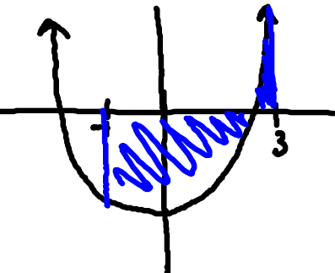

Note: This answer agrees with Example 5 from section 5.2.1!

Example 6: In section 5.2.1 we saw that and we mentioned that the sum on the right is too difficult for us to figure out. Use the FTCP2 to find .

Using the ideas 4.10, we have that is an antiderivative of (we can check this using differentiation). So, since is a continuous function on the interval then by the FTCP2, we know that:
.

Note: At this point, it is very important to take some time to reflect on just how awesome the FTOC is!

Example 7: Find the exact value of .

We note that is a continuous function on the interval . Therefore by the FTCP2 we know that:

Note: This example solves one of the intro examples brought up on the first day of calculus one and that we approximated in section 5.2.2!!!
Example 8: Find the exact value of each of the following.

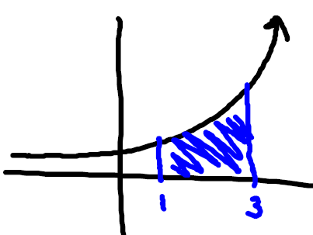
- .

First we note that is continuous on , so by the FTCP2 we know that:

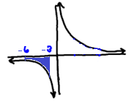
We note that and that is continuous on , so by the FTCP2 we know that: .

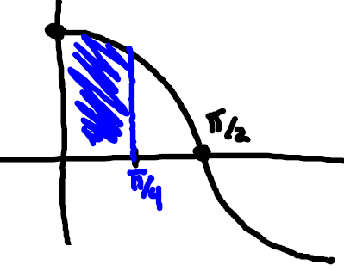
- The area under the cosine curve from 0 to .

We note that is continuous on , so by the FTCP2 we know that:

Example 9: Jeff attempted to compute the following integral but was told by his teacher that his answer is wrong. What is wrong with Jeff’s calculation?
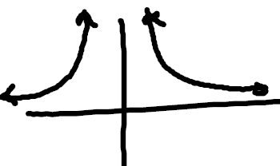
The FTCP2 has been incorrectly applied. Notice that the function is not continuous on the interval because it is discontinuous at . Therefore, Jeff cannot apply FTCP2.

In Calculus II you will discuss ways to approach the calculation of integrals of discontinuous functions!

